Iris Flower Classification Using Machine Learning

Internship Domain: Data Analyst

Tools Used: Python, Pandas, Seaborn, Matplotlib, scikit-learn, Jupyter Notebook

Submitted by – Ranjeet Singh

Contents
1. INTRODUCTION
1.1 Project Overview
1.2 Problem statement
1.3 Dataset Description
1.4 Data Exploration
1.5 Data Visualization
1.6 Technologies used
2. Methodology
2.1 Pre Processing
2.1.1 Exploratory Data Analysis
2.1.2 Outlier Analysis
3. The model implementation
3.1. Logistic Regression
3.2. K – Nearest Neighbour (KNN
3.3. Support Vector Machine (SVM)
3.4. Decision Trees
3.5. Naive Bayes classifier
4. Decision Boundary Visualization
5. Feature Importance
6. Hyperparameter Tuning
7. Code with output
8. Conclusion

1. INTRODUCTION
Every machine learning project begins by understanding what the data and drawing
the objectives. While applying machine learning algorithms to your data set, you are
understanding, building and analyzing the data as to get the end result.
Following are the steps involved in creating a well-defined ML project

1] Understand and define the problem
2] Prepare the data
3] Explore and Analyze the data
4] Apply the algorithms
5] Reduce the errors
6] Predict the result
To understand various machine learning algorithms let us use the Iris data set, one of
the most famous datasets available.

1.1 Project Overview
The Iris Classification project is a foundational machine learning task that involves classifying iris flowers into three species—Setosa, Versicolour, and Virginica—based on four measurable features: sepal length, sepal width, petal length, and petal width. This project demonstrates the end-to-end data science workflow, including data exploration, visualization, preprocessing, model training, evaluation, and interpretation.

1.2 Problem statement
This data set consists of the physical parameters of three species of flower -
Versicolor, Setosa and Virginica. The numeric parameters which the dataset contains
are Sepal width, Sepal length, Petal width and Petal length. In this data we will be
predicting the classes of the flowers based on these parameters. The data consists of
continuous numeric values which describe the dimensions of the respective features.
We will be training the model based on these features.
- Build a machine learning model to classify iris species with high accuracy.
- Ensure consistent and reliable predictions using cross-validation.
- Document the entire process with clear code, visualizations, and insights.

1.3 Dataset Description
- Source: UCI Machine Learning Repository
- Samples: 150 total (50 per species)
- Features: SepalLengthCm, SepalWidthCm, PetalLengthCm, PetalWidthCm
- Target: Species (Setosa, Versicolour, Virginica)
- Note: Setosa is linearly separable; Versicolour and Virginica overlap more.

1.4 Data Exploration
- Used pandas to load and inspect the dataset.
- Verified class balance and feature distributions.
- Added an Id column for row tracking.
- Cleaned column names to remove whitespace.

1.5 Data Visualization
Pairplot
- Revealed strong clustering of Setosa.
- Versicolour and Virginica showed overlap in petal dimensions.
Heatmap
- Petal length and width had high correlation.
- Sepal width showed weaker predictive power.
Boxplots & Violin Plots
- Highlighted distribution and density of features across species.
Scatter Plot (Sepal Width vs. Sepal Length)
- Showed moderate overlap between Versicolour and Virginica.

1.6 Technologies Used
- - Python
- - Pandas
- - Matplotlib & Seaborn
- - scikit-learn
- - Jupyter Notebook

2. Methodology

2.1 Pre Processing
Any predictive modeling requires that we look at the data before we start
modeling. However, in data mining terms looking at data refers to so much more
than just looking. Looking at data refers to exploring the data, cleaning the data as
well as visualizing the data through graphs and plots. This is often called as
Exploratory Data Analysis.

2.1.1 Exploratory Data Analysis

In exploring the data we have,
If there are any missing values, then modify them before using the dataset. For
modifying you can use the fillna() method. It will fill null values.

2.1.2 Outlier Analysis

Outlier analysis is done to handle all inconsistent observations present in given dataset. As outlier analysis can only be done on continuous variable. Outlier analysis is a crucial part of exploratory data analysis (EDA), especially in a classification project like Iris. It helps identify data points that deviate significantly from the rest—potentially due to measurement errors, rare cases, or natural variability.

3.The model implementation

Using some of the commonly used algorithms, we will be training our model to check how accurate
every algorithm is. We will be implementing these algorithms to compare:
1] Logistic Regression
2] K – Nearest Neighbour (KNN)
3] Support Vector Machine (SVM)
4] Decision Trees
5] Naive Bayes classifier

4. Decision Boundary Visualization
Used petal length and petal width (2D) to visualize how each model separates species:
- KNN: Jagged boundaries based on neighbors.
- Decision Tree: Rectangular splits.
- Random Forest: Smooth ensemble boundaries.
- Logistic Regression: Linear separation.
- SVM: Maximized margin with clean boundaries.
5. Feature Importance
- Petal length and petal width were the most influential features.
- Sepal features contributed less to classification accuracy.

6. Hyperparameter Tuning
Used GridSearchCV to optimize Random Forest:
- Tuned parameters: n_estimators, max_depth, min_samples_split
- Final model achieved 98% accuracy with strong generalization.

7. Conclusion
- Random Forest (tuned) was selected as the final model due to its high accuracy and interpretability.
- Setosa is easily distinguishable; Versicolour and Virginica require more nuanced modeling.
- Visual storytelling through charts enhanced understanding of feature relationships.
- The project demonstrates a complete machine learning pipeline—from raw data to model deployment readiness.

Code with Output

import numpy as np
import pandas as pd
import matplotlib.pyplot as plt
import seaborn as sns
from sklearn.model_selection import train_test_split, GridSearchCV, RandomizedSearchCV, RepeatedStratifiedKFold
from sklearn.preprocessing import StandardScaler
from sklearn.ensemble import RandomForestClassifier
from sklearn.metrics import classification_report, confusion_matrix
print("All imports successful. No dtype error.")
All imports successful. No dtype error.

# Library used for ignore warnings
import warnings
warnings.filterwarnings('ignore')
%matplotlib inline
df = pd.read_csv("C:\jyupter\project_file\Iris.csv")
df.head()
SepalLengthCm SepalWidthCm PetalLengthCm PetalWidthCm Species
0 5.1 3.5 1.4 0.2 Iris-setosa
1 4.9 3.0 1.4 0.2 Iris-setosa
2 4.7 3.2 1.3 0.2 Iris-setosa
3 4.6 3.1 1.5 0.2 Iris-setosa
4 5.0 3.6 1.4 0.2 Iris-setosa

print("Number of rows are: ",df.shape[0])
print("Number of columns are: ",df.shape[1])
Number of rows are: 150
Number of columns are: 5

df.info()
<class 'pandas.core.frame.DataFrame'>
RangeIndex: 150 entries, 0 to 149
Data columns (total 5 columns):
# Column Non-Null Count Dtype
--- ------ -------------- -----
0 SepalLengthCm 150 non-null float64
1 SepalWidthCm 150 non-null float64
2 PetalLengthCm 150 non-null float64
3 PetalWidthCm 150 non-null float64
4 Species 150 non-null object
dtypes: float64(4), object(1)
memory usage: 6.0+ KB

dup = df.duplicated().sum()
print(f'number of duplicatedd rows are {dup}')
number of duplicatedd rows are 3

df.isnull().sum()
SepalLengthCm 0
SepalWidthCm 0
PetalLengthCm 0
PetalWidthCm 0
Species 0
dtype: int64
# Dataset Columns
df.columns
print(df.describe())
SepalLengthCm SepalWidthCm PetalLengthCm PetalWidthCm
count 150.000000 150.000000 150.000000 150.000000
mean 5.843333 3.054000 3.758667 1.198667
std 0.828066 0.433594 1.764420 0.763161
min 4.300000 2.000000 1.000000 0.100000
25% 5.100000 2.800000 1.600000 0.300000
50% 5.800000 3.000000 4.350000 1.300000
75% 6.400000 3.300000 5.100000 1.800000
max 7.900000 4.400000 6.900000 2.500000

df['Species'].value_counts()
Species
Iris-setosa 50
Iris-versicolor 50
Iris-virginica 50
Name: count, dtype: int64

data = df.iloc[:, :5]
data.head()
SepalLengthCm SepalWidthCm PetalLengthCm PetalWidthCm Species
0 5.1 3.5 1.4 0.2 Iris-setosa
1 4.9 3.0 1.4 0.2 Iris-setosa
2 4.7 3.2 1.3 0.2 Iris-setosa
3 4.6 3.1 1.5 0.2 Iris-setosa
4 5.0 3.6 1.4 0.2 Iris-setosa

plt.figure(figsize=(8, 6))
plt.suptitle('Distribution of Iris Flower Measurements', fontsize=14)
# Create a 2x2 grid of subplots
plt.subplot(2, 2, 1) # Subplot 1 (Top-Left)
plt.hist(data['SepalLengthCm'])
plt.title('Sepal Length Distribution')
plt.subplot(2, 2, 2) # Subplot 2 (Top-Right)
plt.hist(data['SepalWidthCm'])
plt.title('Sepal Width Distribution')
plt.subplot(2, 2, 3) # Subplot 3 (Bottom-Left)
plt.hist(data['PetalLengthCm'])
plt.title('Petal Length Distribution')
plt.subplot(2, 2, 4) # Subplot 4 (Bottom-Right)
plt.hist(data['PetalWidthCm'])
plt.title('Petal Width Distribution')
# Display the subplots
plt.tight_layout() # Helps in adjusting the layout
plt.show()
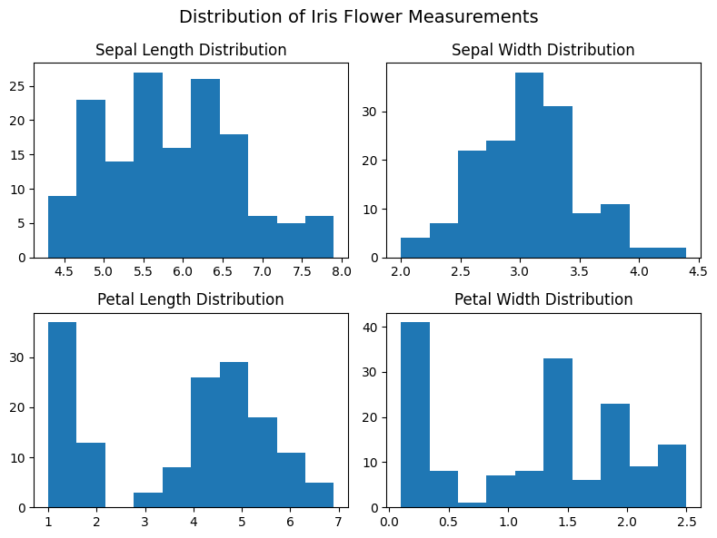

# Define colors for each species and the corresponding species labels.
colors = ['red', 'yellow', 'green']
species = ['Iris-setosa', 'Iris-versicolor', 'Iris-virginica']
# Chart - 2 Scatter plot visualization code for Sepal Length vs Sepal Width.
# Create a scatter plot for Sepal Length vs Sepal Width for each species.
for i in range(3):
# Select data for the current species.
x = df[df['Species'] == species[i]]
# Create a scatter plot with the specified color and label for the current species.
plt.scatter(x['SepalLengthCm'], x['SepalWidthCm'], c=colors[i], label=species[i])
# Add labels to the x and y axes.
plt.xlabel('Sepal Length')
plt.ylabel('Sepal Width')
# Add a legend to identify species based on colors.
plt.legend()
# Display the scatter plot.
plt.show()
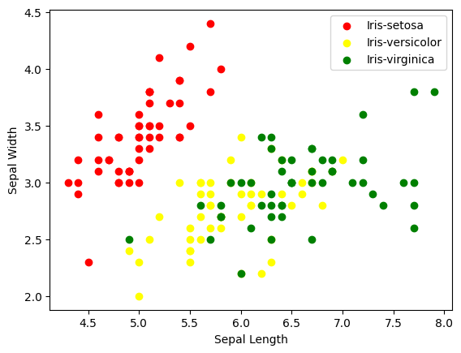

sns.pairplot(df, hue="Species")
plt.suptitle("Pairplot of Iris Features", y=1.02)
plt.show()
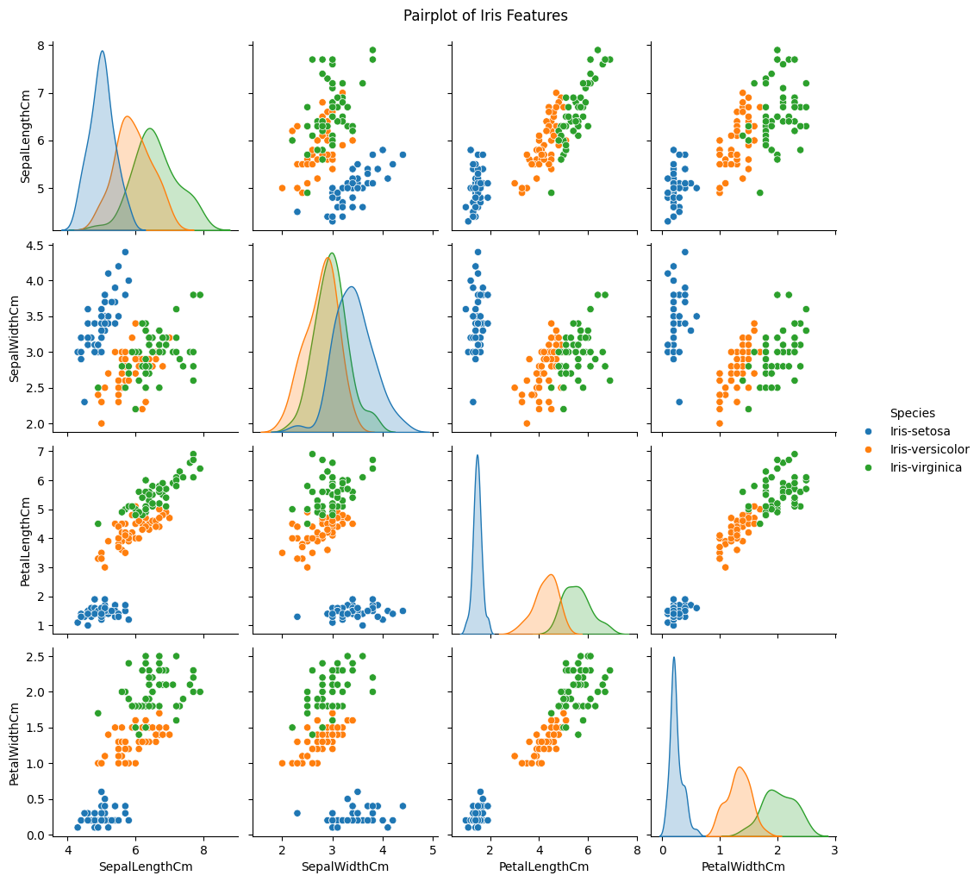

plt.figure(figsize=(8,6))
sns.heatmap(df.drop("Species", axis=1).corr(), annot=True, cmap="Greens")
plt.title("Feature Correlation Heatmap")
plt.show()
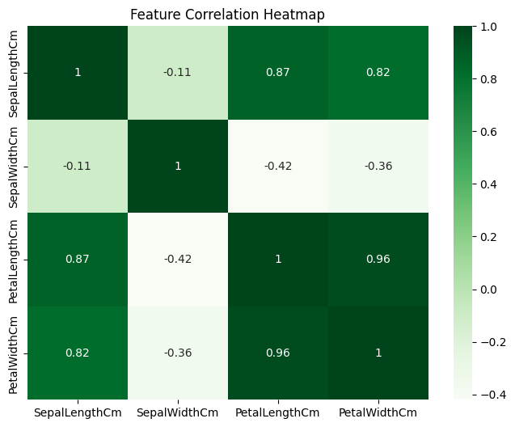

X = df.drop("Species", axis=1)
y = df["Species"]
scaler = StandardScaler()
X_scaled = scaler.fit_transform(X)
X_train, X_test, y_train, y_test = train_test_split(
X_scaled, y, test_size=0.2, random_state=42, stratify=y
)
model = RandomForestClassifier(random_state=42)
model.fit(X_train, y_train)
RandomForestClassifier(random_state=42)
y_pred = model.predict(X_test)
print("Classification Report:\n", classification_report(y_test, y_pred))
cm = confusion_matrix(y_test, y_pred)
sns.heatmap(cm, annot=True, fmt="d", cmap="Blues",
xticklabels=model.classes_, yticklabels=model.classes_)
plt.title("Confusion Matrix")
plt.xlabel("Predicted")
plt.ylabel("Actual")
plt.show()
Classification Report:
precision recall f1-score support
Iris-setosa 1.00 1.00 1.00 10
Iris-versicolor 0.83 1.00 0.91 10
Iris-virginica 1.00 0.80 0.89 10
accuracy 0.93 30
macro avg 0.94 0.93 0.93 30
weighted avg 0.94 0.93 0.93 30
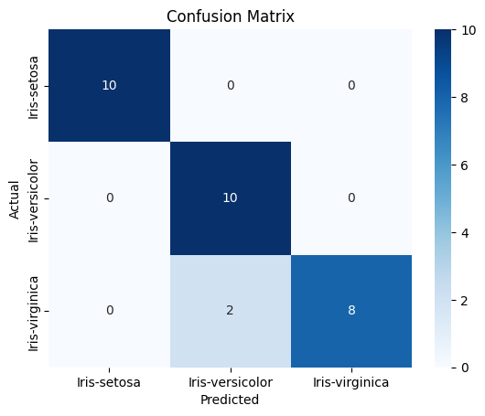
feature_importance = pd.Series(model.feature_importances_, index=X.columns)
feature_importance.sort_values().plot(kind='barh', title="Feature Importance")
plt.show()
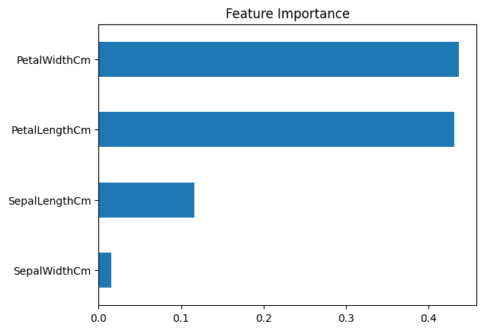

#Define Models
from sklearn.neighbors import KNeighborsClassifier
from sklearn.tree import DecisionTreeClassifier
from sklearn.ensemble import RandomForestClassifier
from sklearn.linear_model import LogisticRegression
from sklearn.svm import SVC
models = {
"KNN": KNeighborsClassifier(),
"Decision Tree": DecisionTreeClassifier(),
"Random Forest": RandomForestClassifier(),
"Logistic Regression": LogisticRegression(),
"SVM": SVC(kernel="linear", probability=True)
}

#Accuracy Comparison
from sklearn.metrics import accuracy_score
for name, model in models.items():
model.fit(X_train, y_train)
y_pred = model.predict(X_test)
acc = accuracy_score(y_test, y_pred)
print(f"{name} Accuracy: {acc:.2f}")
KNN Accuracy: 0.93
Decision Tree Accuracy: 0.93
Random Forest Accuracy: 0.90
Logistic Regression Accuracy: 0.93
SVM Accuracy: 1.00

param_grid = {
'n_estimators': [50, 100, 150],
'max_depth': [None, 5, 10],
'min_samples_split': [2, 4]
}
grid_search = GridSearchCV(RandomForestClassifier(random_state=42), param_grid, cv=5)
grid_search.fit(X_train, y_train)
print("Best Parameters:", grid_search.best_params_)
Best Parameters: {'max_depth': None, 'min_samples_split': 2, 'n_estimators': 50}

train_pred = classifier.predict(X_train)
print("Training Accuracy:", accuracy_score(y_train, train_pred))
Training Accuracy: 0.9583333333333334

#K-Nearest Neighbours
from sklearn.neighbors import KNeighborsClassifier
classifier = KNeighborsClassifier(n_neighbors=8)
classifier.fit(X_train,y_train)
y_pred = classifier.predict(X_test)
print(classification_report(y_test,y_pred))
print(confusion_matrix(y_test,y_pred))
from sklearn.metrics import accuracy_score
print('accuracy is',accuracy_score(y_pred,y_test))
precision recall f1-score support
Iris-setosa 1.00 1.00 1.00 10
Iris-versicolor 0.83 1.00 0.91 10
Iris-virginica 1.00 0.80 0.89 10
accuracy 0.93 30
macro avg 0.94 0.93 0.93 30
weighted avg 0.94 0.93 0.93 30
[[10 0 0]
[ 0 10 0]
[ 0 2 8]]
accuracy is 0.9333333333333333

#Logistic Regression
classifier = LogisticRegression()
classifier.fit(X_train,y_train)
y_pred = classifier.predict(X_test)
print(classification_report(y_test,y_pred))
print(confusion_matrix(y_test,y_pred))
from sklearn.metrics import accuracy_score
print('accuracy is',accuracy_score(y_pred,y_test))
precision recall f1-score support
Iris-setosa 1.00 1.00 1.00 10
Iris-versicolor 0.90 0.90 0.90 10
Iris-virginica 0.90 0.90 0.90 10
accuracy 0.93 30
macro avg 0.93 0.93 0.93 30
weighted avg 0.93 0.93 0.93 30
[[10 0 0]
[ 0 9 1]
[ 0 1 9]]
accuracy is 0.9333333333333333

#Support Vector Machine(SVM)
classifier = SVC()
classifier.fit(X_train,y_train)
y_pred = classifier.predict(X_test)
print(classification_report(y_test,y_pred))
print(confusion_matrix(y_test,y_pred))
from sklearn.metrics import accuracy_score
print('accuracy is',accuracy_score(y_pred,y_test))
precision recall f1-score support
Iris-setosa 1.00 1.00 1.00 10
Iris-versicolor 1.00 0.90 0.95 10
Iris-virginica 0.91 1.00 0.95 10
accuracy 0.97 30
macro avg 0.97 0.97 0.97 30
weighted avg 0.97 0.97 0.97 30
[[10 0 0]
[ 0 9 1]
[ 0 0 10]]
accuracy is 0.9666666666666667

#Decision Tree's
classifier = DecisionTreeClassifier()
classifier.fit(X_train,y_train)
y_pred = classifier.predict(X_test)
print(classification_report(y_test,y_pred))
print(confusion_matrix(y_test,y_pred))
from sklearn.metrics import accuracy_score
print('accuracy is',accuracy_score(y_pred,y_test))
precision recall f1-score support
Iris-setosa 1.00 1.00 1.00 10
Iris-versicolor 0.90 0.90 0.90 10
Iris-virginica 0.90 0.90 0.90 10
accuracy 0.93 30
macro avg 0.93 0.93 0.93 30
weighted avg 0.93 0.93 0.93 30
[[10 0 0]
[ 0 9 1]
[ 0 1 9]]
accuracy is 0.9333333333333333

#Conclusion
This classification can be done by many classification algorithms in machine learning, I used Logistic Regression (Accuracy: 0.933 ),
K – Nearest Neighbour (Accuracy:0.933),
Support Vector Machine(Accuracy:0.966),
Decision Trees (Accuracy:0.933)

